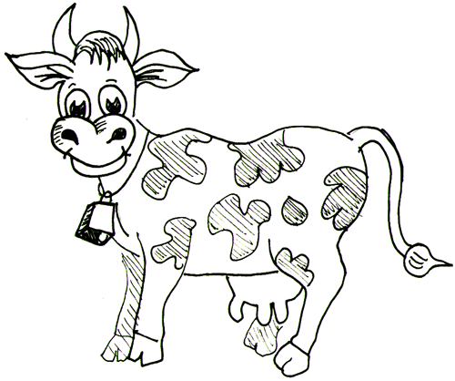
Name: ________________________________________

COWs--Homework Reading Strategy
Completing Connections, Observations and Wonderings (COWs) when your read is an interactive reading strategy focused on reader comprehension. Instead of answering a set of questions, the reader is focusing on their personal reaction and understanding of the material. You will be completing COWs on a wide variety of readings for our homework in Global History. The Cs and Qs should be written in your composition notebook using the format and directions below.

Label: What did you read? Clearly label the source (textbook chapter and section, article title and source, etc)
Connections & Claims | Observations | Wonderings
This is where you should make your connections (this reminds me of a similar event or perspective, etc.) and your claims (this is the reason why such and such happened, or I bet if this had never happened, then….) | Here is where you should write your “notes”. This includes:  - Name and dates  - Key words and their definitions  - Major events  - The main messages of the cartoon/map/chart/graph  - Anything you think will be important for you to know and remember  - Important quotes from people and their meaning  - Quotes from the article or book that you think summarize well or make an excellent point | This is where you write down things you wonder about, questions you may have.
You are NOT limited to one page. In fact, you are encouraged to take extensive COWs. Your COWs will be checked in class the day they are due. If students struggled with the reading or have a lot of questions, comments or connections, we will address them that day in class. Once every week or two you will hand in your Cs and Qs for comments and grade.
Need a sentence starter?

Connections & Claims  • This makes sense now because….  • No, I think _____ was wrong because….  • I agree/disagree with you/the author. This means ….  • As first I thought (fill in detail), but now I think ….  • This part is really saying….  • This is good because…  • This is hard because…  • This is confusing because….  • This reminds me of …  • This part is like …  • This person (fill in name) is like (fill in name) because …  • This is similar to …  • The differences are …  • If this hadn’t/had ... , then …..would/would not have happened  • The key person/event/ruler/movement is … because ….  • This time period reminds me of… | Wonderings:  • Why did…  • What’s this part about…  • How is this (fill in detail) like this (fill in detail)….  • What would happen if …  • Why …  • Who is …  • What does this section (fill in detail) mean …  • Do you think that …  • I don’t get this part here…

